The Parent’s Guide to Google Classroom!
- Google Classroom is a digital link to your child’s learning!
- Teachers use Google Classroom to share assignments, homework or announcements to all of their pupils.

What is Google Classroom?
- Your child should have received their Glow log-in details – Usernames were sent out before the holidays. You can email the school to receive them.
- Password Crimond1
- If this does not work, or you have lost the user name, please get in contact with me at hilda.creighton@aberdeenshire.gov.uk

Getting Started
- Click on the Google Chrome Icon

Step 1

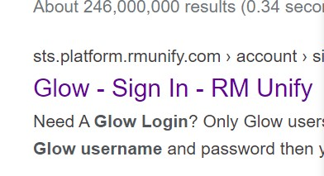
Step 2
•
Type in “Glow” on the search engine.
•
The website
Glow
-
Sign In
-
RM Unify
should appear.
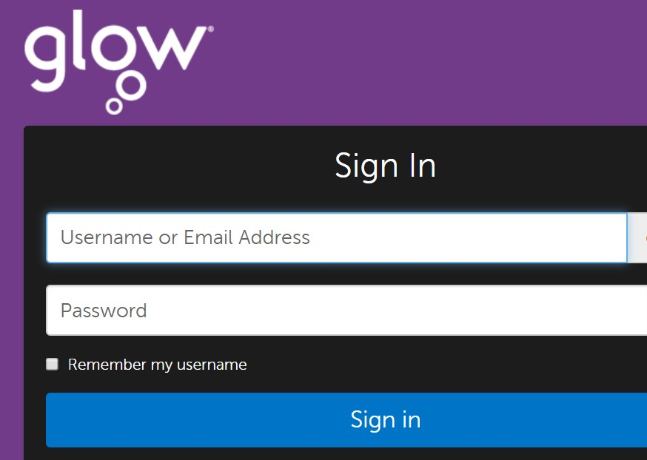
• Using your child’s username and password, log on to Glow.

Step 3

Step 4
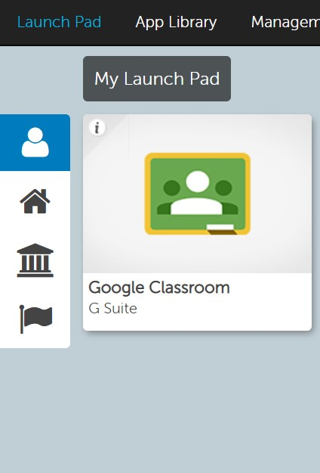
Your child should see the Google Classroom tile on their Launch Pad.
Don’t worry if it’s not there – you can easily find it by searching “Google Classroom”
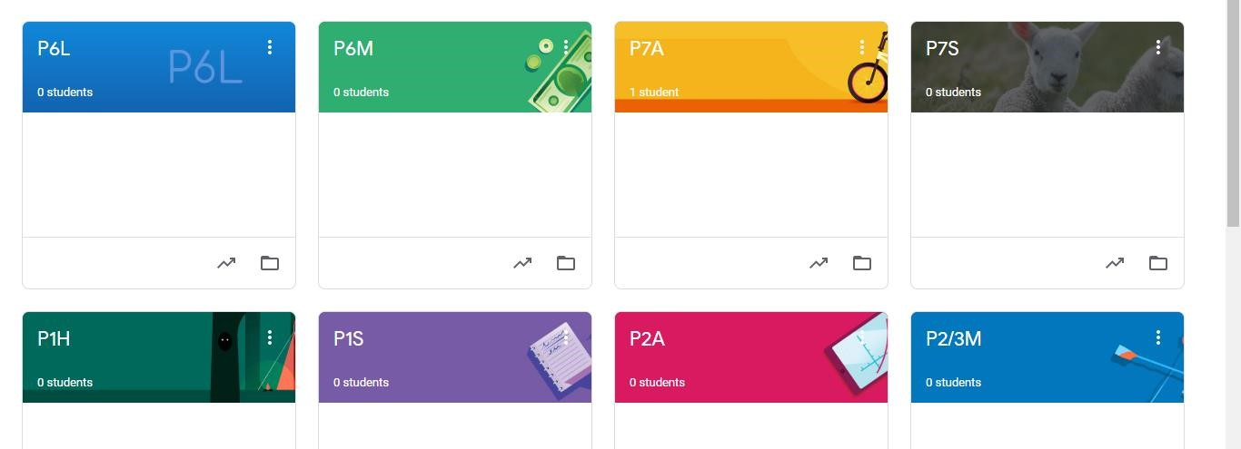
Step 5
•
You should be a member of a class
that has already been set up. Click
on your class name.
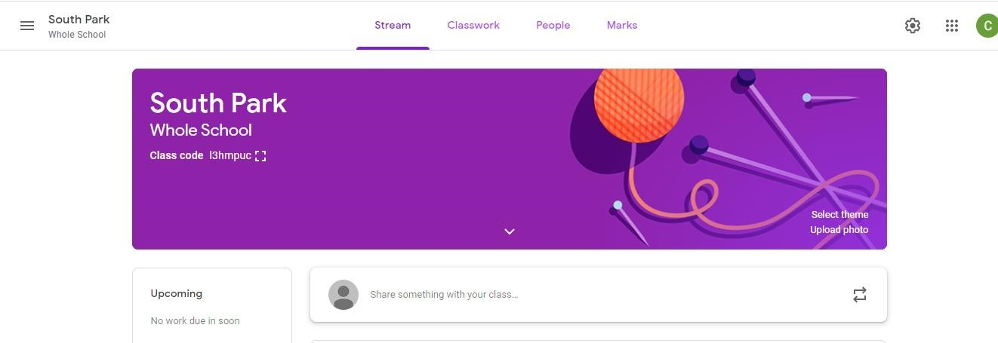
Step 6
You are in!

